1.)

**Entered tree** : (A(B(E(K,L),F),D(H(M),I)))

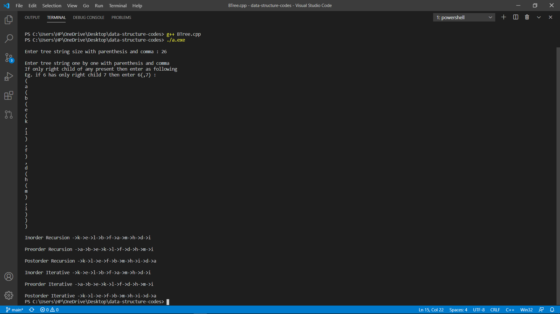

2.)

**Entered tree** : A(B(D(H,I),E(J,K)),C(F(L),G))s

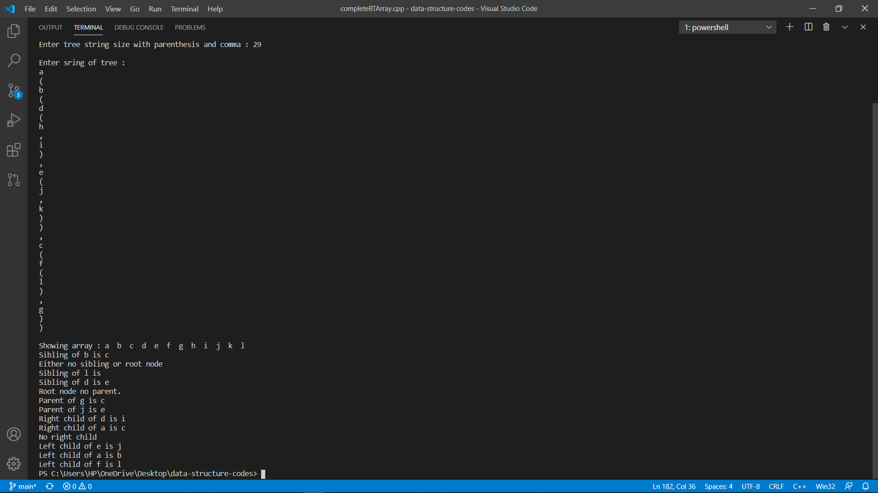

3.)

**Entered tree** :

50 ( 48 ( 30 ( 20(15,25), 32(31,35) ) ),70 ( 65 (, 67(66,69) ), 90(, 98(94,99) ) ) )

**Searches** : (i)20

(ii)100

(iii)32

(iv)67

(v)66

